Use-Case Realization Report (Analysis)
Refund Money

Issue 3.0
Revision History
Date | Issue | Description | Author
13 July 2000 | 1.0 | First Issue | Howard Russon
2 August 2001 | 2.0 | Revised for MTech Unit 3 in 2001 | Howard Russon
21 July 2004 | 3.0 | Revised for MTech Unit 3 in 2004 | Howard Russon

Table of Contents
1. Brief Description 4
2. Flow of Events 4
2.1 Standard Flow 4
2.2 Exceptions 4
3. Interaction Diagrams 5
3.1 Collaboration Diagram: Refund Money 5
4. Participating Objects 5
5. Class Diagrams 6
5.1 Class Diagram: Refund Money 6
6. Derived Requirements 6

Use-Case Realization Report
Refund Money

Brief Description
This abstract use case enables refunds of the money entered to be issued to the Customer.

Flow of Events
The standard flow of events for this use case and any exceptions are described in the following subsections. The events are described in terms of Actors and Analysis Objects.

Standard Flow
This use case is used by use case Coin Input and Select Brand to give refunds to the Customer. The flow of events is shown in section 3.1 and described as follows:
- The Transaction Controller will initiate the refunding of all the money entered by the Customer by using operation RefundCash of Coin Receiver.
- The Coin Receiver will delete all references (stored in its attributes) to the entered Coins.
- The Coin Receiver will then instruct the Refund/Change Tray Display to display the amount of money refunded by using operation DisplayChange.
- Finally, the Coin Receiver will reset the Total Money Inserted Display to 0.00 by using operation InitialDisplay.

Exceptions
The following exceptions have been identified:
- No Coins Entered. If zero Coins have so far been entered during the current transaction, then refund requests will be ignored.
- Terminate Request Too Late. If the terminate request is made after the dispensing of the drink has commenced, then the request will be ignored.

Interaction Diagrams

Collaboration Diagram: Refund Money
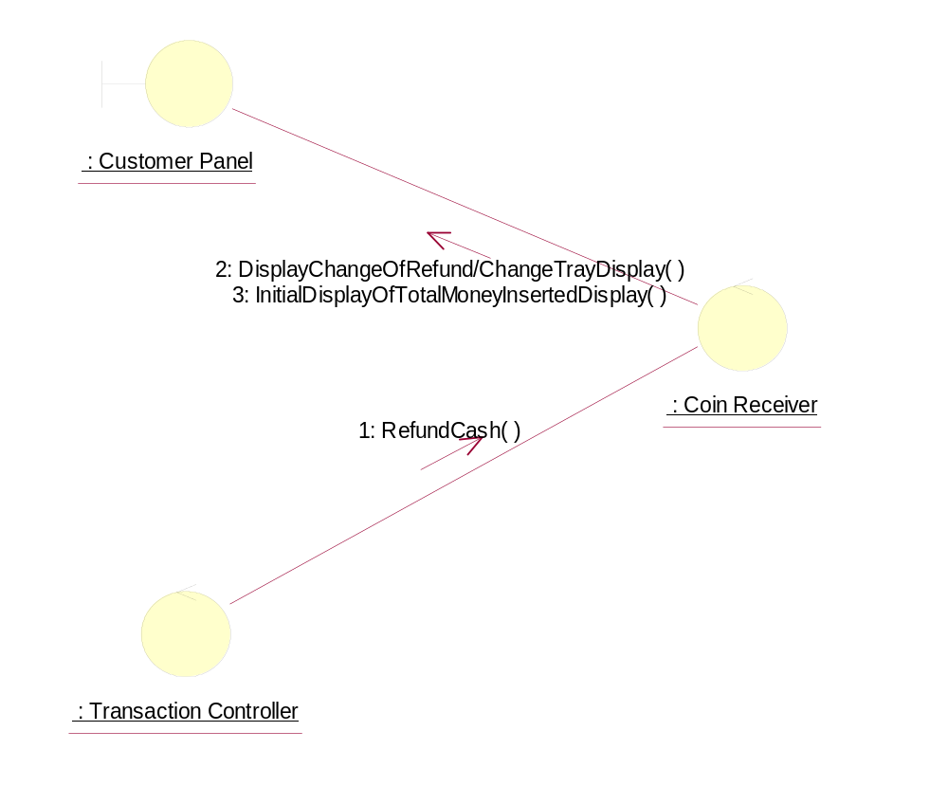

Participating Objects
: Coin Receiver
This control object manages the input and storage of Coins.
: Customer Panel
This panel simulates the vending machine's customer interface panel. It will enable the user (the Customer) to:
1 insert coins;
2 select brands;
3 terminate transaction.
It will also provide the following display functions:
1 display total money inserted;
2 indicate coin not valid;
3 indicate no change available;
4 display the value of the change to be collected;
5 display an icon representing the dispensed drink.
: Transaction Controller
This control object coordinates the customer transactions for selection of a drink brand, coin input, storage of coins and termination requests for ongoing transactions.

Class Diagrams

Class Diagram: Refund Money
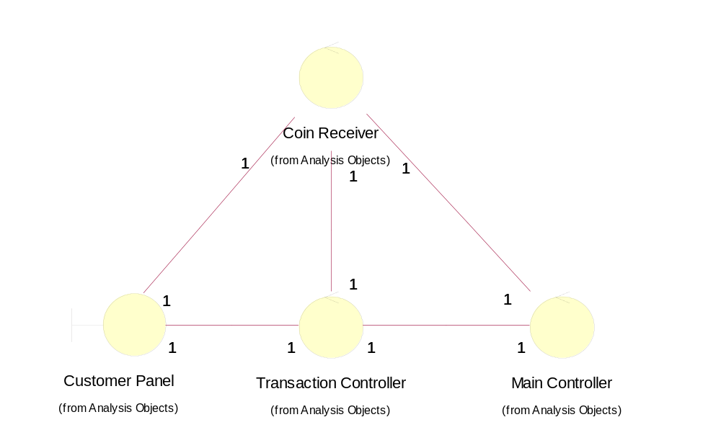

Derived Requirements
There are no special requirements associated with the host implementation. However, in the target implementation a cash tray is required to be built into the Customer Panel.

